1. Presented by - Prabha Pareek

CAPSTONE PROJECT - NORTHWIND SALES ANALYSIS

The Northwind Sales dataset, consist of tables related to customers, orders, employees, suppliers, shippers, products and categories. The aim of this project is to anlayse the given dataset and provide solution to the given problems using power BI, SQL and Excel(EDA). This document descibes in detail the steps followed throughout the process and the inferences drawn from it

OVERVIEW

**PROCESS OVERVIEW**

Extracting data from github:

Downloaded the northwind sales dataset from provided repository link. Containing the information related to customers, employees, supplier, orders and products.

Importing data:

SQL : Through Table data import wizard

Power BI : Through tranform data icon imported all the tables

Excel : Through power query

Data Transformation:

Removed unnecessary column eg. photo, image etc.

Created calculated columns, measures, also hide unwanted columns and marked primary key in power BI.

Created SQL Queries.

Created pivot table if required in excel

Dashboard in power BI:

Created visualization and dashboard according to the questions asked.

EDA in Excel:

Created visualization through the filterd data obtained from SQL query

Documentation:

Make power point presentation with video explaination

**OBJECTIVE**

The overarching goal for the Northwind Sales dataset is to derive actionable insights across various dimensions including customers, suppliers, products, orders, and categories. Leveraging SQL, Exploratory Data Analysis (EDA), and Power BI, the specific objectives are:

**Customer Insights:**

Utilize KPIs to analyze customer behavior, preferences, and profitability. Identify top customers based on revenue, frequency of purchases, and customer satisfaction metrics.

**Supplier Analysis:**

Evaluate supplier performance using key metrics such as on-time delivery, product quality, and overall reliability. Identify top-performing suppliers and areas for improvement.

**Product Performance:**

Analyze product-related KPIs to understand sales trends, identify top-selling products, and assess inventory turnover. Optimize product offerings based on popularity, profitability, and customer demand.

**Order Efficiency:**

Assess order-related metrics to enhance operational efficiency. This includes analyzing order processing times, fulfillment accuracy, and identifying patterns to streamline order management processes.

**Category Popularity:**

Evaluate category-wise KPIs to understand the popularity trends of different product categories. Optimize product placement, marketing strategies, and inventory based on category performance.

**SIGNIFICANCE**

The Northwind Sales dataset stands as a trove of strategic significance, offering a comprehensive lens into the intricate dynamics of a sales-driven enterprise. With its structured tables encompassing customers, suppliers, products, orders, and categories, this dataset becomes a powerhouse for deriving actionable insights.

Leveraging the robust combination of SQL, Exploratory Data Analysis (EDA), and Power BI, the dataset's objectives are clear and impactful. Customer insights, garnered through key performance indicators (KPIs), pave the way for a nuanced understanding of customer behavior, preferences, and profitability. Supplier analysis, focusing on metrics like on-time delivery and product quality, allows for the identification of top-performing suppliers, enabling informed decisions and enhanced collaboration.

In conclusion, the Northwind Sales dataset serves as a dynamic and realistic tool for honing skills, conducting analyses, and gaining valuable insights into various aspects of sales operations and business management. Its structured design and diverse data make it a valuable asset for professionals, students, and businesses engaged in database management, analytics, and strategic decision-making.Data Dictionary

**DATA DICTIONARY**

**Customers Table**

|  |  |  |
| --- | --- | --- |
| COLUMN | DESCRIPTION | DATATYPE |
| Customer ID (PK) | A unique identifier for each customer | Text |
| Company name | Name of customer’s company | Text |
| Contact name | Name of customer | Text |
| Contact title | Title of customer in their company | Text |
| Address | Customer’s address | Text |
| City | Customer’s city | Text |
| Country | Customer’s country | Text |

**Order Details Table**

|  |  |  |
| --- | --- | --- |
| COLUMN | DESCRIPTION | DATATYPE |
| Order ID (FK) | Identifier for each order | Integer |
| Product ID (FK) | Identifier for each product | Integer |
| Unit price | Price of each unit | Float |
| Quantity | Order Quantity | Integer |
| Discount | Discount given on orders | Float |

**Employees Table**

|  |  |  |
| --- | --- | --- |
| COLUMN | DESCRIPTION | DATATYPE |
| Employee ID (PK) | A unique identifier for each employee | Integer |
| Last name | Employee’s last name | Text |
| First name | Employee’s first name | Text |
| Title | Title of employee in their company | Text |
| Title of courtesy |  | Text |
| Birth date | Employee’ s birthday | Date |
| Hire date | Joining date of employee | Date |
| Address | Employee’s address | Text |
| City | Employee’s city | Text |
| Country | Employee’s country | Text |
| Notes | Employee’s qualifications | Text |
| Reports to | Employee ID to whom they are reporting | Integer |

**Orders Table**

|  |  |  |
| --- | --- | --- |
| COLUMN | DESCRIPTION | DATATYPE |
| Order ID (PK) | A unique identifier for each order | Integer |
| Customer ID (FK) | Identifier for each customer | Integer |
| Employee ID (FK) | Identifier for each employee | Integer |
| Order date | Date on which order placed | Date |
| Required date | Date before which order should be delivered | Date |
| Shipped date | Date on which order shipped | Date |
| Ship via (FK) | Shipping mode | Integer |
| Ship name | Customer’s company name | Text |
| Ship address | Shipping address | Text |
| Ship city | Shipping city | Text |
| Ship country | Shipping country | Text |

**Shippers Table**

|  |  |  |
| --- | --- | --- |
| COLUMN | DESCRIPTION | DATATYPE |
| Shippers ID (PK) | A unique identifier for each shipper | Integer |
| Company name | Shipper’ s company name | Text |

**Products Table**

|  |  |  |
| --- | --- | --- |
| COLUMN | DESCRIPTION | DATATYPE |
| Product ID (PK) | A unique identifier for each product | Integer |
| Product name | Product’s name | Text |
| Supplier ID (FK) | A identifier for each supplier | Integer |
| Category ID (FK) | A identifier for each category | Integer |
| Unit price | Price per product unit | Float |
| Units in stock | Stock in inventory | Integer |
| Units on order | Units for which order is placed | Integer |
| Reorder level | Product’s rating on reorder | Integer |
| Discontinued | Product is available for sale or not | Integer |

**Suppliers Table**

|  |  |  |
| --- | --- | --- |
| COLUMN | DESCRIPTION | DATATYPE |
| Supplier ID (PK) | A unique identifier for each supplier | Integer |
| Company name | Supplier’s company name | Text |
| Contact name | Supplier’s name | Text |
| Contact title | Supplier’s department | Text |
| Address | Supplier’s address | Text |
| City | Supplier’s city | Text |
| Country | Supplier’s country | Text |

**Categories Table**

This table stores information about the product categories. It includes fields for category ID, category name, and description.

|  |  |  |
| --- | --- | --- |
| COLUMN | DESCRIPTION | DATATYPE |
| Category ID (PK) | A unique identifier for each category | Integer |
| Category name | Category ‘s name | Text |
| Description | Items lies in category | Text |

**ER DIAGRAM**

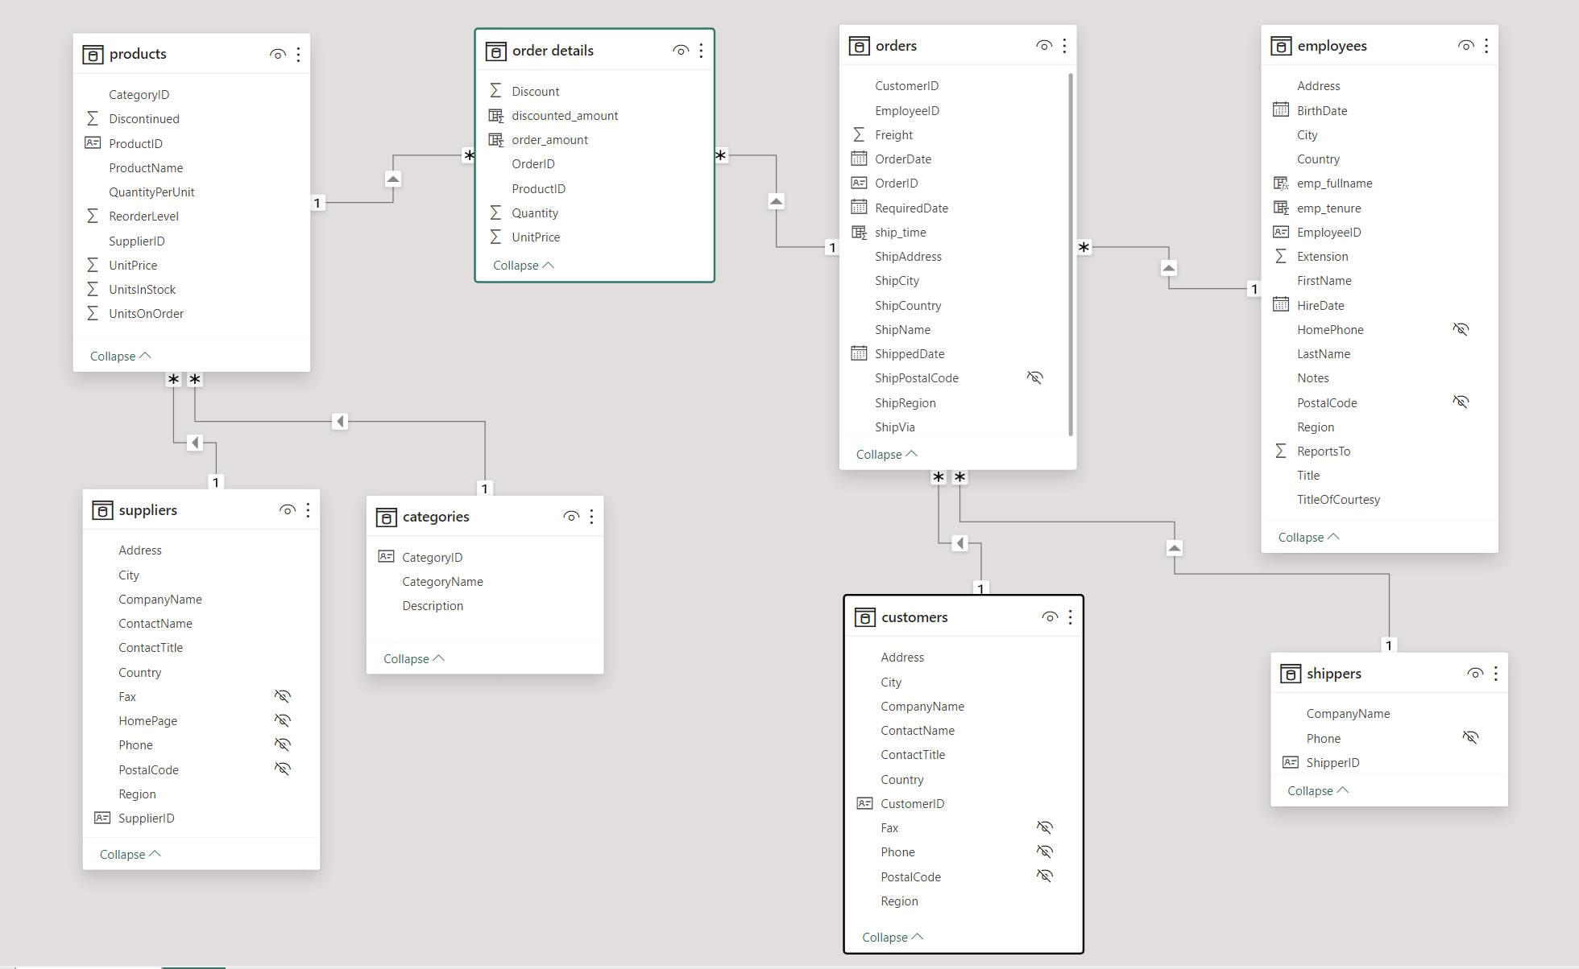

**POWER BI SOLUTONS**

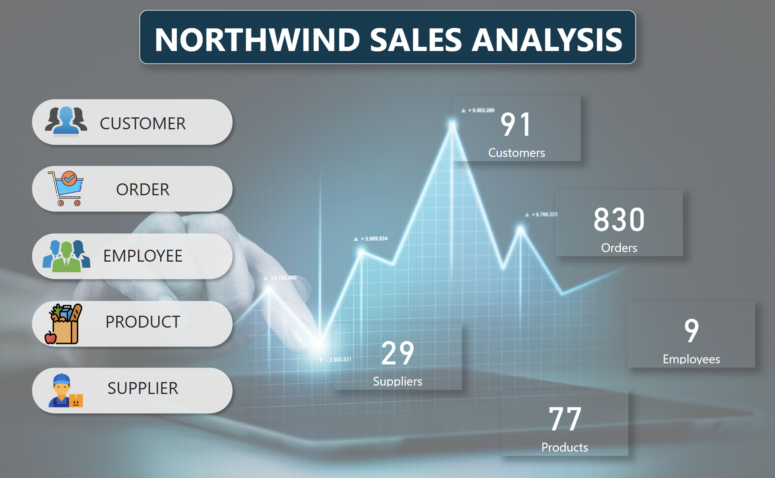

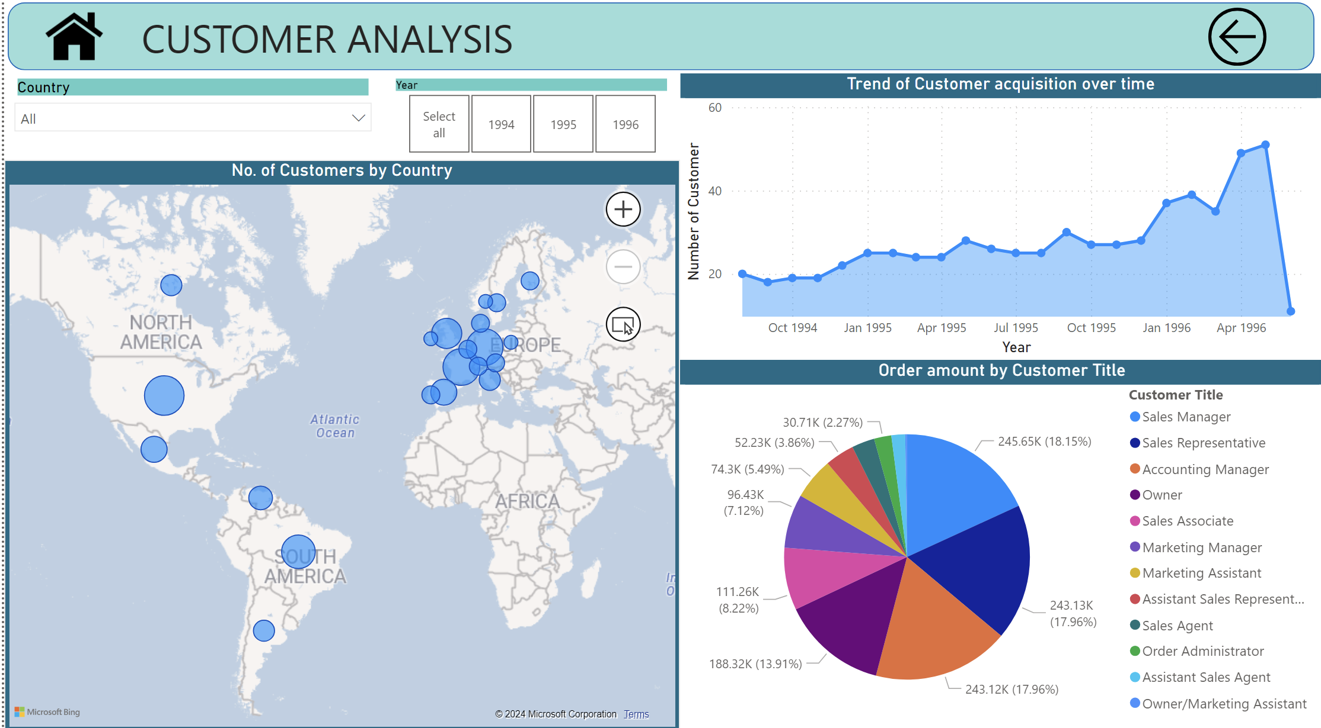

Q 1 How does customer distribution vary across different regions or customer segments? Can we visualize it on a map or bar chart?

Based on the country report, it is evident that the countries USA, France, Germany, and Brazil stand out with a substantial number of customers, reflecting a strong and robust market presence in these regions. The high customer count in these countries suggests a successful and widespread adoption of the products or services offered by the business. This favorable customer distribution can be attributed to effective marketing strategies, a strong brand presence, and alignment with the preferences of these diverse markets.

On the flip side, countries such as Ireland, Poland, and Norway exhibit comparatively lower customer numbers. While this may indicate a smaller market share in these regions, it also presents opportunities for targeted growth and expansion efforts. Understanding the factors influencing customer engagement in these countries can provide valuable insights for refining marketing approaches, addressing specific local needs, and potentially increasing market share.

In conclusion, the analysis underscores the importance of recognizing and responding to variations in customer distribution across different countries. By acknowledging the strengths and weaknesses in each market, businesses can tailor their strategies to maximize success, foster customer loyalty, and drive sustainable growth.



Q 2 What is the trend in customer acquisition over time? Can we create a line chart or area chart to display it?

The presented graph unveils a compelling narrative of a continuous ascent in the number of customers from August 1994 to May 1996, underscoring a positive and robust growth trajectory. This upward trend is indicative of the effectiveness of customer acquisition strategies, reflecting the enduring appeal of the products or services offered by the business.

It is crucial to acknowledge and bring attention to a minor dip observed in June 1996. This temporary decline is attributed to incomplete data for that specific month. Recognizing and transparently addressing such data gaps is pivotal for ensuring an accurate interpretation of the overall trend.

In the context of a consistent upward trajectory with occasional fluctuations, as evidenced in the graph, the implication is a resilient and adaptable business model. The ability to navigate challenges, even those arising from incomplete data, underscores the business's resilience and capacity to maintain a positive growth trajectory.

Moving forward, it is recommended to address the data gap and ensure comprehensive data collection. This commitment to data integrity will not only enhance the precision of future analyses but also fortify the reliability of insights derived from the customer acquisition trends. This, in turn, will support informed decision-making and contribute to sustained success for the business.



Q 3 Can we visualize the distribution of customer demographics such as age, gender, or income using histograms or pie charts?

The analysis of customer demographics, specifically focusing on contact titles in relation to total order amounts, provides valuable insights into the purchasing behavior associated with different roles within the customer base.

The data reveals a distinct trend wherein customers holding titles such as Sales Manager, Sales Representative, and Accounting Manager exhibit significantly higher total order amounts. This finding suggests that individuals occupying these roles play a pivotal role in driving substantial sales for the business. Their influence and decision-making authority are reflected in the larger order volumes, underscoring the importance of fostering relationships with these key stakeholders.

Contrastingly, customers with titles like Owner and Marketing Assistant appear to contribute less to the total order amounts. This insight prompts a closer examination of the dynamics associated with these roles, exploring potential factors that may influence their purchasing decisions. Understanding the specific needs and preferences of customers in these roles can inform targeted strategies to enhance engagement and potentially increase their contribution to overall sales.

In conclusion, aligning sales and marketing efforts with the distinct characteristics of customer segments based on contact titles is crucial. By tailoring strategies to address the unique requirements of Sales Managers, Sales Representatives, and Accounting Managers, businesses can maximize their revenue potential. Simultaneously, devising targeted approaches for customers with titles like Owner and Marketing Assistant can unlock opportunities to elevate their engagement and, subsequently, their contribution to the overall sales landscape.



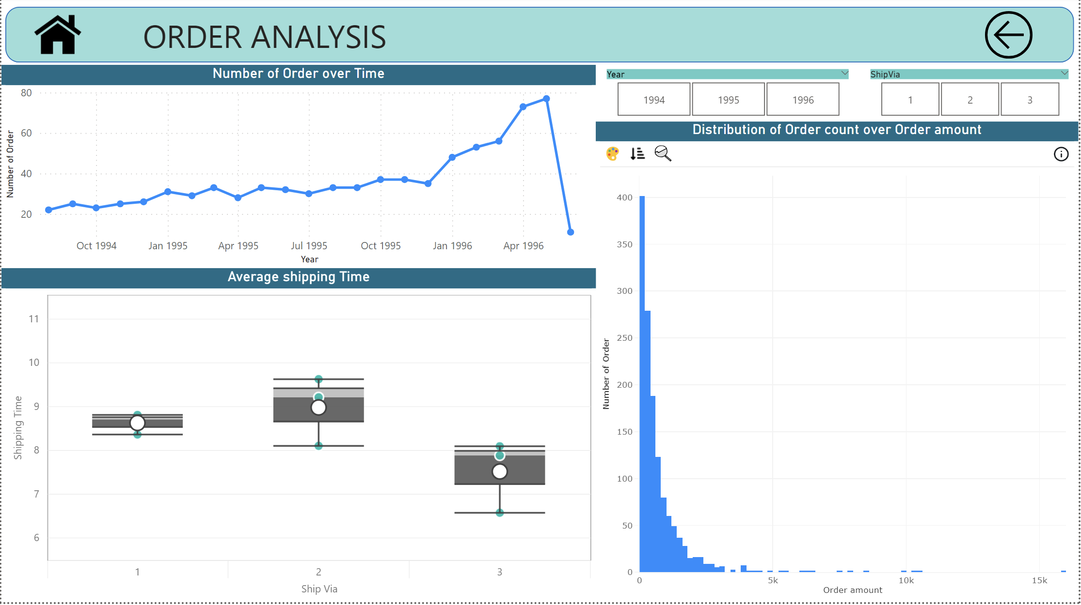

Q 4 How does order volume change over time? Can we create a time series chart or stacked bar chart to visualize it?

The graphical representation illustrates a consistent upward trend in order volume over the period from August 1994 to May 1996. However, a slight dip is observed in June 1996, attributed to incomplete data during that specific month. Notably, there is a significant surge in orders in 1996, indicating a noteworthy increase in customer engagement and transactional activity during that period. This spike in orders could be indicative of various factors such as marketing initiatives, seasonal trends, or changes in customer behavior. Further analysis of the contextual factors surrounding this surge could provide deeper insights into the dynamics of customer interactions during this impactful period.

The visual representation of the data reveals a consistent and positive trajectory in order volume from August 1994 to May 1996, indicating a general increase in customer transactions over time. However, a slight decline is observed in June 1996, and it's important to note that this dip may be attributed to incomplete data for that specific month.

A noteworthy observation is the substantial spike in orders during the year 1996. This significant increase in transactional activity suggests a period of heightened customer engagement and purchasing behavior. Exploring the underlying reasons for this surge, such as specific marketing campaigns, product launches, or external factors influencing customer behavior, can provide valuable insights into the drivers of this remarkable uptick.

In summary, while the overall trend reflects a positive growth in order volume, the specific anomalies, like the dip in June 1996 and the surge in orders during that year, warrant further investigation to understand the contextual factors influencing these fluctuations.



Q 5 What is the distribution of order values? Can we create a histogram or box plot to display it?

The analysis of the distribution of order count over order amount reveals a distinct pattern in customer purchasing behavior. The majority of orders, as reflected by the highest order count, are associated with order amounts less than $200. This suggests that a significant portion of customers tends to make smaller transactions, possibly indicating frequent, lower-value purchases.

Conversely, as the order amount increases beyond $2.5k, there is a noticeable decline in order count. This implies that higher-value transactions are less frequent among the customer base. Customers may be more cautious or selective when making substantial purchases, resulting in a lower count of such orders.

This insight underscores the importance of catering to a diverse range of customer preferences and spending behaviours. While there is a substantial volume of smaller transactions, businesses may need targeted strategies to encourage higher-value transactions. Understanding the factors influencing customer decisions at different order amount tiers can guide businesses in optimizing their product offerings, pricing strategies, and marketing approaches to align with customer preferences.



Q 6 Can we visualize the average order processing time or shipping duration using a bar chart or box plot?

The visualization illustrates the relationship between different shipping methods ("Ship Via") and their respective shipping times. Notably, Ship Via 1 and Ship Via 2 exhibit similar shipping times, while Ship Via 3 stands out with significantly shorter shipping durations.

The green dots across the years provide a temporal perspective on how these shipping methods have performed over time. The consistency in shipping times for Ship Via 1 and Ship Via 2 suggests a reliable and stable delivery duration associated with these methods. On the other hand, Ship Via 3 consistently shows faster shipping times, represented by the clustering of green dots below those of Ship Via 1 and 2.

This analysis suggests that Ship Via 3 might be a more expedited or efficient shipping option compared to Ship Via 1 and Ship Via 2. The visual representation allows for a quick understanding of the shipping dynamics associated with different methods, aiding in strategic decision-making regarding the choice of shipping options based on speed and reliability. Businesses can leverage this information to optimize their shipping strategies, potentially enhancing customer satisfaction through timely and reliable deliveries.



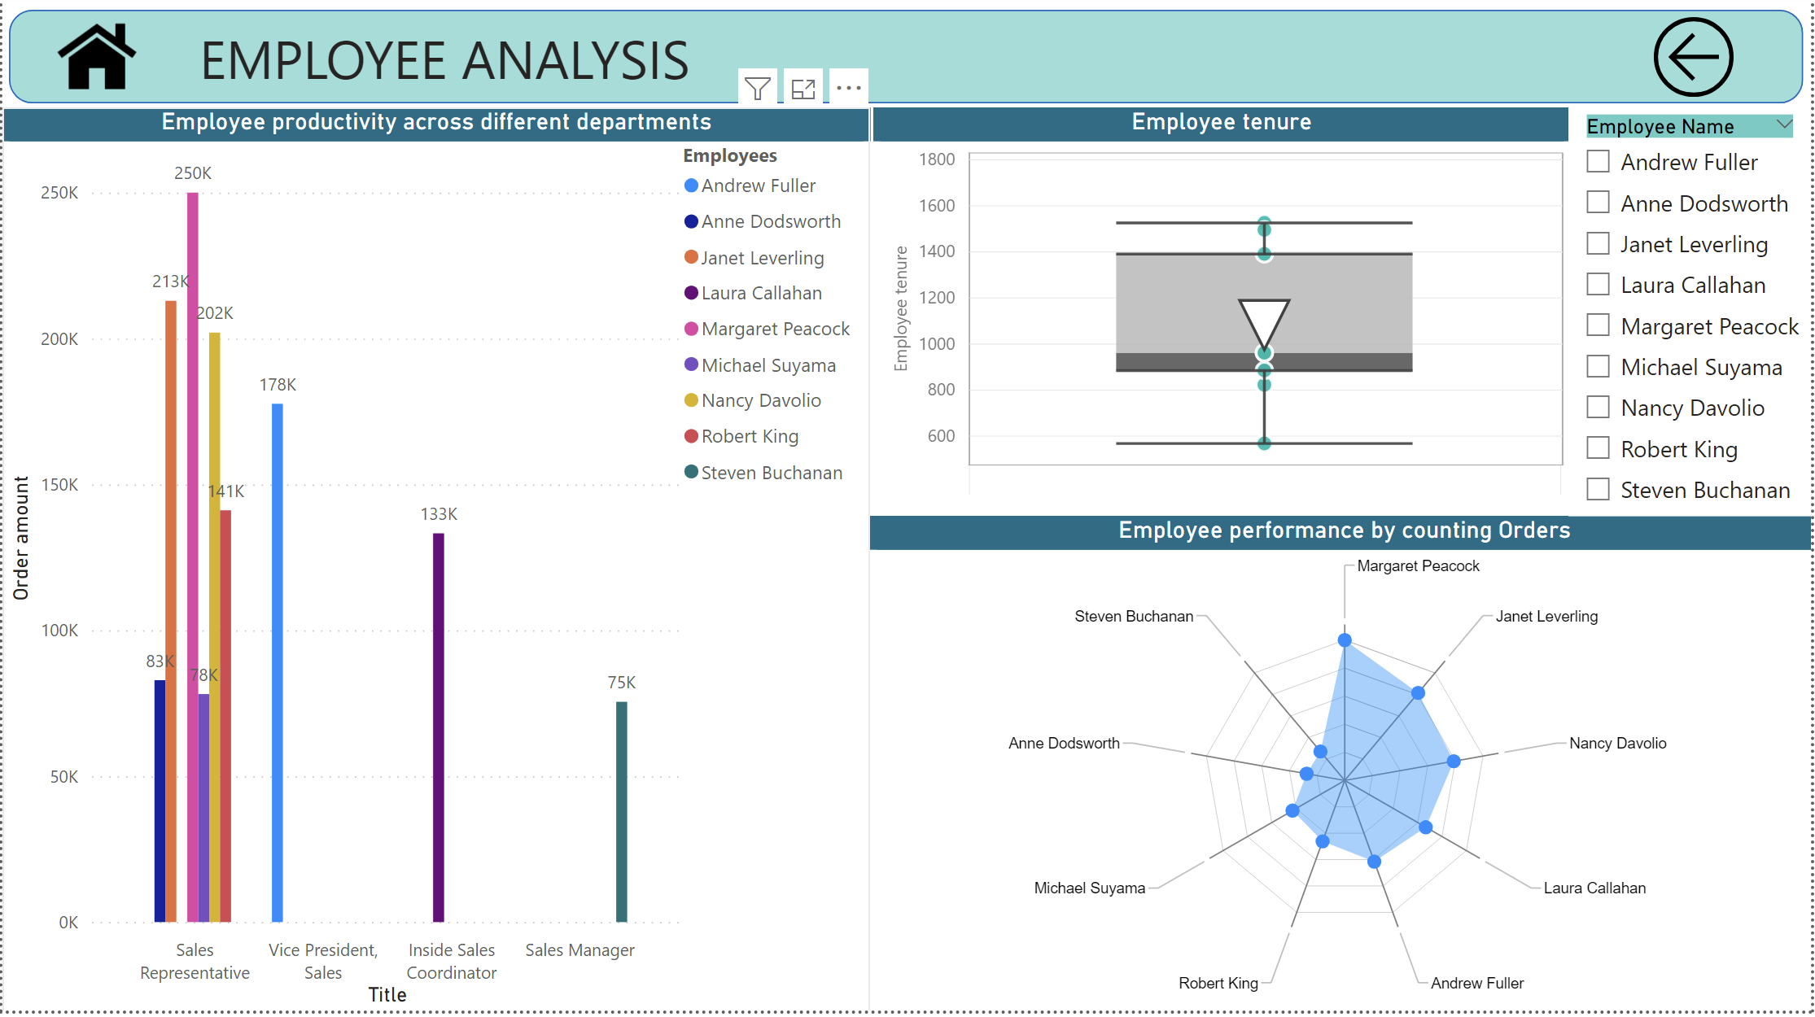

Q 7 How does employee productivity vary across different departments or job roles? Can we create a stacked bar chart or grouped column chart to visualize it?

The graph provides valuable insights into employee productivity, showcasing the sales generated by each employee within their respective departments. Notably, the Sales Representative department emerges as the top-performing department, with the three highest contributors being Michel, Janet, and Nancy. These individuals exhibit remarkable sales performance, contributing significantly to the overall sales figures.

Following closely are other noteworthy departments contributing to the overall productivity. The Vice President, Inside Sales Coordinator, and Sales Manager departments also stand out as strong performers, albeit slightly trailing the Sales Representative department.

This analysis sheds light on the key contributors to sales within each department, allowing businesses to recognize and reward top-performing employees. Additionally, it aids in identifying areas of strength within the organization and highlights potential opportunities for improvement or optimization in departments where sales may be lagging. Overall, the visualization serves as a valuable tool for workforce management and strategic decision-making to enhance overall sales performance.



Q 8 What is the distribution of employee tenure? Can we create a histogram or box plot to display it?

The average employee tenure in the company is calculated to be 1082 days, reflecting the typical duration of employment across the workforce. However, when examining individual employee tenures, notable variations are observed.

Janet boasts the highest tenure among employees, having dedicated 1526 days to the company. Following closely is Nancy, whose tenure is the second-highest within the organization. Andrew also demonstrates a significant period of service.

On the contrary, Anne's tenure stands out as notably lower compared to the average and the tenures of other employees. This discrepancy prompts further exploration into factors that may contribute to variations in employee retention, such as job satisfaction, career growth opportunities, or organizational culture.

The analysis of individual tenures not only provides insights into the company's overall employee stability but also highlights specific cases that may warrant attention. Addressing the factors influencing lower tenures, such as Anne's, can contribute to a more comprehensive understanding of employee engagement and aid in the development of strategies to enhance overall employee retention.



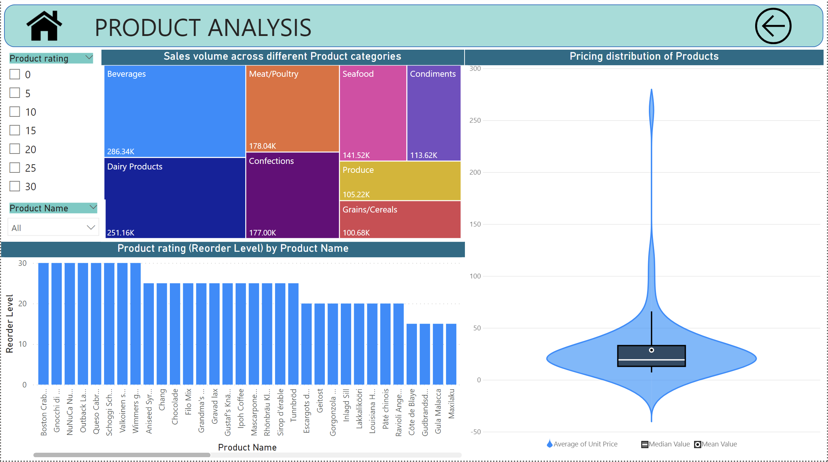

Q 9 Can we visualize employee performance ratings or KPIs using a radar chart or bullet graph?

This radar chart provides a visual representation of employee performance based on the count of orders associated with each employee. Margaret emerges as the standout performer, exhibiting the highest order count among all employees. In contrast, Steve and Anne register lower order counts, indicating a potential variance in their contributions to sales-related activities.

The radar chart is an effective tool for showcasing individual strengths and areas for improvement within the sales team. It allows for a quick and intuitive comparison of employee performance metrics, facilitating insights into the distribution of workload and productivity across team members.

The visualization aids management in recognizing top-performing employees, identifying potential areas for skill development or additional support, and making informed decisions to optimize the overall efficiency of the sales team.



Q 10 What is the distribution of product ratings or reviews? Can we create a histogram or stacked bar chart to visualize it?

This bar graph illustrates the distribution of product ratings, categorizing them into intervals such as 0, 5, 10, 15, 20, 25, and 30. It provides an overview of how products are rated, with higher ratings indicating better perceived quality. Notably, the chart reveals that products with a rating of 30 are considered excellent, while those with a rating of 0 are perceived as the least favorable.

The visualization allows stakeholders to quickly identify the overall sentiment towards products based on customer ratings. Products achieving higher ratings can be interpreted as meeting or exceeding customer expectations, while those with lower ratings may require attention or improvement.

This analysis aids in making informed decisions about product quality, guiding potential adjustments, and informing strategies to enhance customer satisfaction and loyalty.

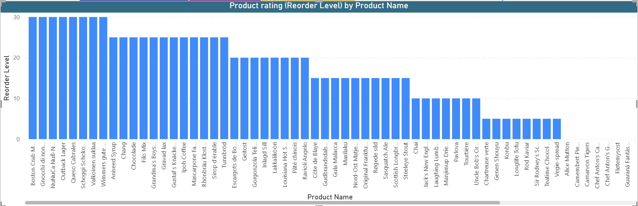

Q 11 How does the sales volume vary across different product categories? Can we create a bar chart or treemap to display it?

The tree chart depicts the sales volume across different product categories, showcasing a hierarchy of sales distribution. Notably, the chart reveals that the "Beverages" category contributes the highest sales volume, indicating a strong performance in terms of revenue generation. On the other hand, the "Grains" category appears to have significantly lower sales, suggesting a comparatively lower demand for products within this category.

This visual representation offers a quick and insightful overview of the relative performance of various product categories within the sales dataset. Stakeholders can easily identify which categories are driving the majority of sales and those that may require closer attention or strategic initiatives to boost performance.

The tree chart is a valuable tool for decision-makers, enabling them to allocate resources effectively, tailor marketing strategies, and optimize product offerings based on the observed sales patterns across different product categories.

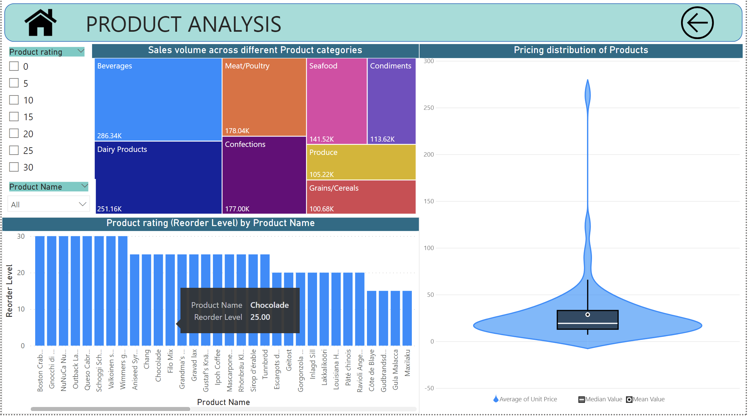

Q 12 Can we visualize the pricing distribution of products using a box plot or violin plot?

This violin graph provides a visual representation of the pricing distribution of products, highlighting key statistical measures such as the mean, median, and average unit price. The width of the violin plot at different points along the vertical axis reflects the density of pricing data at those specific values.

The central tendency measures, including the mean and median, offer insights into the typical or central pricing points within the dataset. The broader shape of the violin plot illustrates the overall distribution of prices, showcasing areas of concentration and potential skewness.

Stakeholders can use this visualization to quickly grasp the spread of pricing data, identify common pricing trends, and understand the variability in product prices. The violin graph serves as a valuable tool for decision-makers involved in pricing strategies, allowing them to make informed decisions based on a comprehensive understanding of the product pricing landscape.



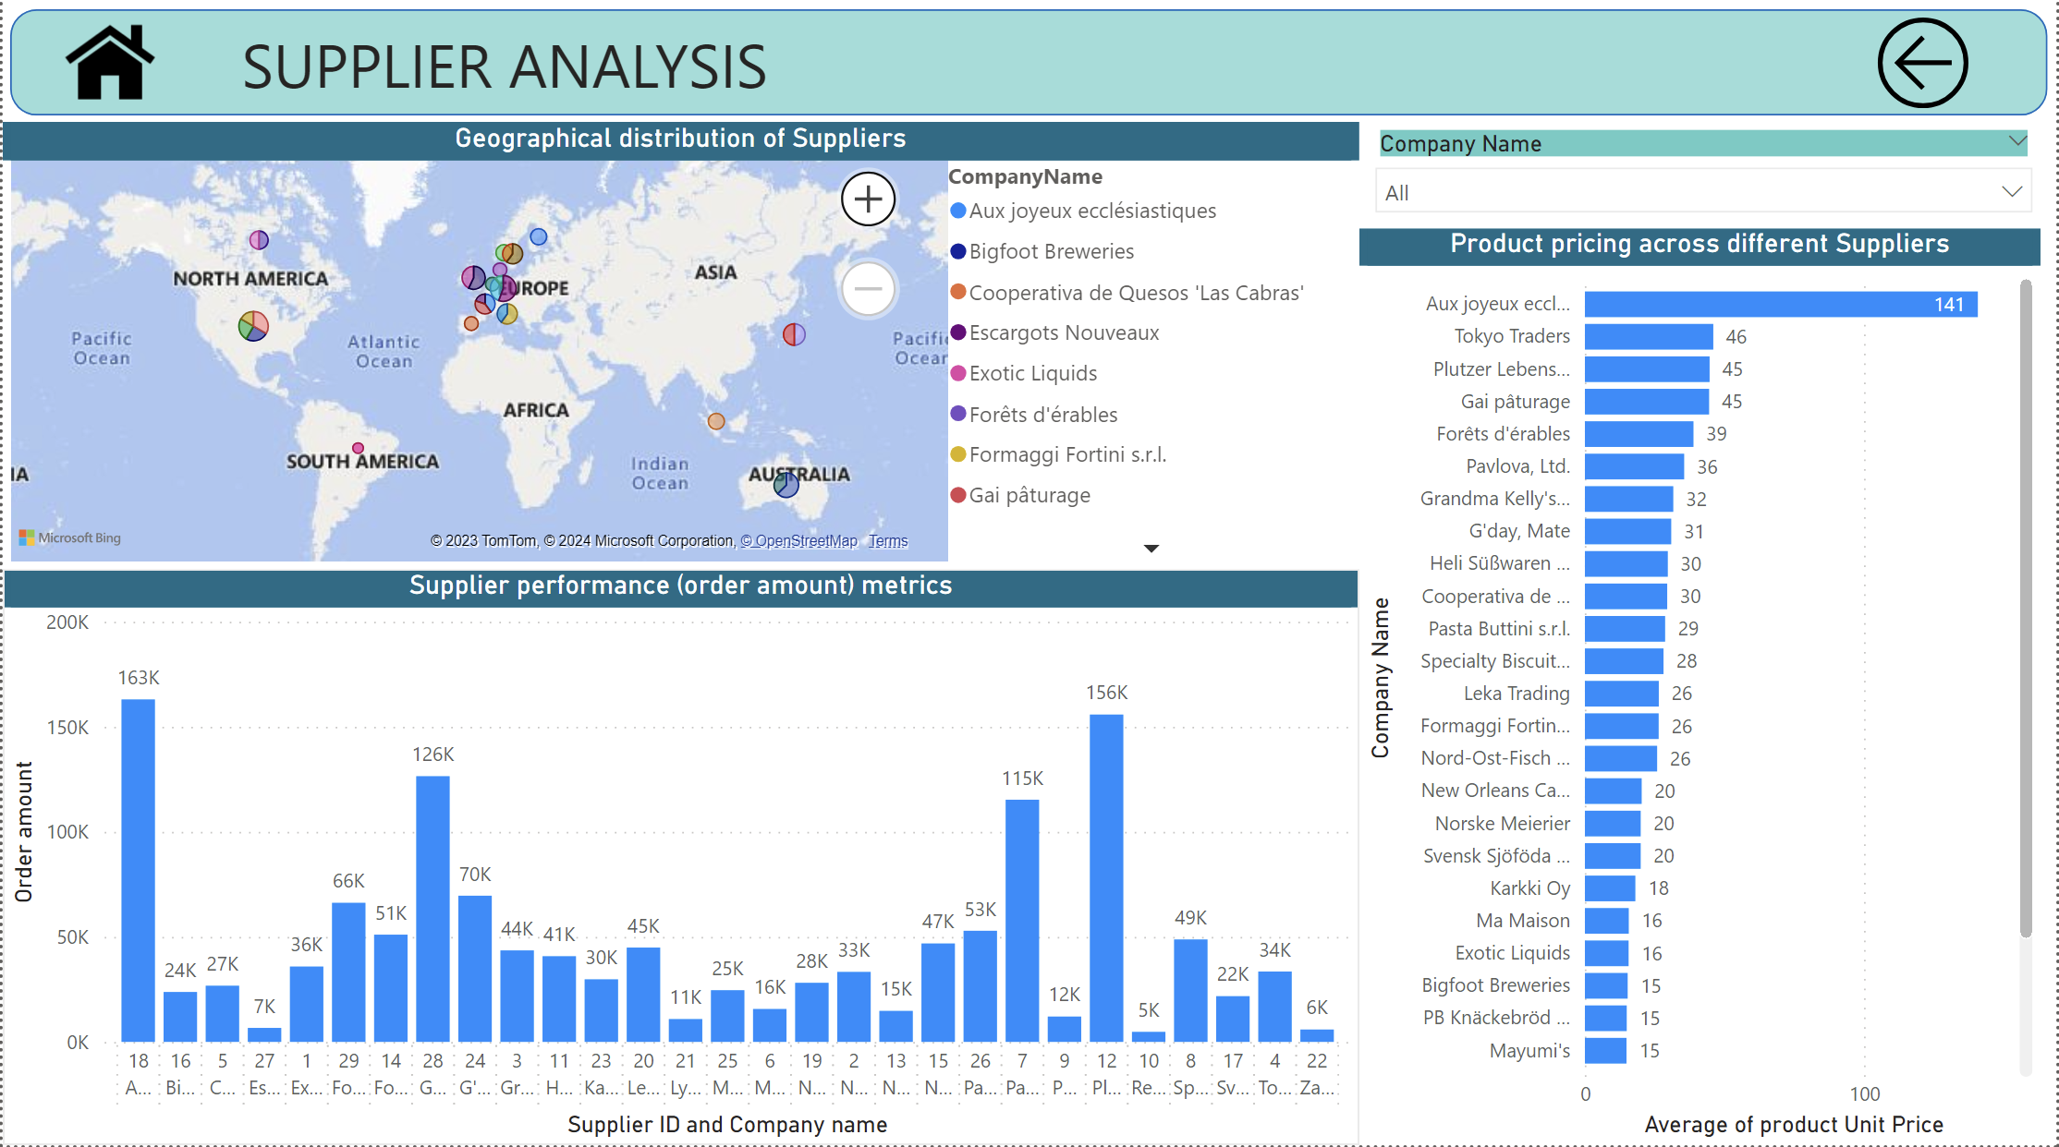

Q 13 What is the distribution of supplier ratings or performance metrics? Can we create a bar chart or radar chart to visualize it?

This graph illustrates the revenue generated by each supplier, providing valuable insights into their respective performances. Supplier ID 18 emerges as the top revenue generator, followed by suppliers 12 and 28. On the contrary, suppliers such as 10, 22, and 27 appear to contribute less to the overall revenue, indicating variations in supplier performance.

The visualization enables stakeholders to quickly identify key contributors to revenue and assess the relative impact of each supplier on the company's financial outcomes. This information can guide strategic decisions related to supplier relationships, procurement, and resource allocation.

The graph serves as a valuable tool for procurement and finance teams, allowing them to prioritize and optimize supplier engagements based on their individual revenue contributions.

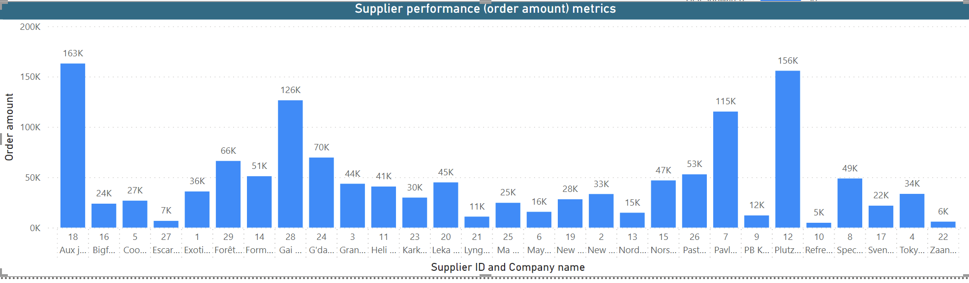

Q 14 How does the cost or pricing structure vary across different suppliers? Can we create a box plot or stacked bar chart to display it?

This graph displays the unit prices of various products, revealing interesting insights into the pricing distribution. Notably, one product, 'Aux Joyeux ecclesiastiques,' stands out with an exceptionally high price compared to others. Conversely, the product with the lowest unit price is identified as 'refrescos americanas LTDA.'

Understanding the pricing distribution is crucial for strategic decision-making, allowing businesses to assess the market positioning of their products and identify opportunities for price optimization or market expansion. By pinpointing both high and low-priced products, companies can tailor their pricing strategies to align with market dynamics and consumer preferences.

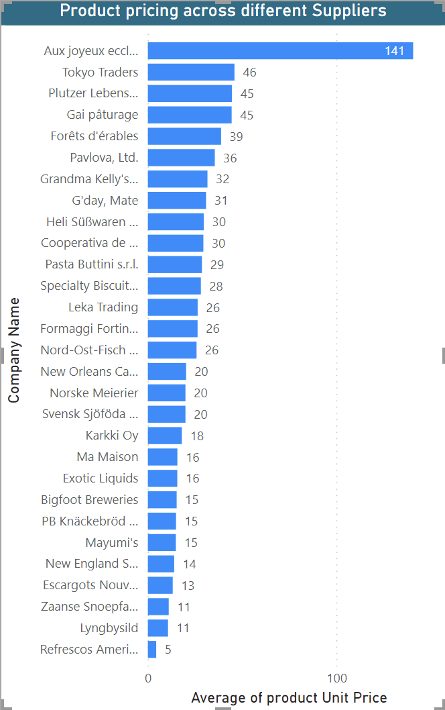

Q 15 Can we visualize the geographical distribution of suppliers using a map or bubble chart?

This geographical graph provides valuable insights into the distribution of supplier companies across different countries. The United States emerges as the country with the highest number of suppliers, followed by France and Germany. Conversely, several countries, such as Spain, Brazil, Finland, among others, are served by only one supplier.

Understanding the geographical distribution of suppliers is essential for businesses to assess their global footprint, identify potential market gaps, and strategically plan their supply chain operations. The concentration of suppliers in specific regions may influence logistical considerations, market penetration strategies, and overall business planning.



**EDA SOLUTONS**

Q 1 What are the key factors influencing customer retention or loyalty based on the dataset?

The criteria for identifying loyal customers in this dataset is based on the number of orders placed. Specifically, customers who have placed more than 10 orders are classified as loyal customers. This classification helps businesses recognize and differentiate customers who engage in frequent and consistent transactions, allowing for targeted strategies such as loyalty programs, personalized promotions, and enhanced customer relationship management to nurture and retain these valuable customers.

The analysis of various factors, including suppliers, customer's country, and ship via, did not reveal any discernible pattern or correlation with customer loyalty. Based on the available data, it can be concluded that customer loyalty does not exhibit a clear association with the specified parameters. This highlights the complexity of customer loyalty and suggests that it may be influenced by factors not captured in the current dataset or may vary on a case-by-case basis. Further exploration and additional data may be needed to better understand the dynamics of customer loyalty in this context.

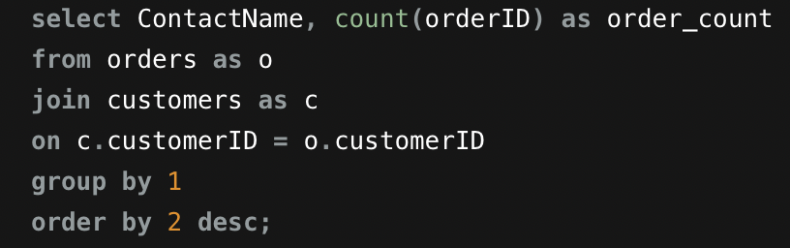

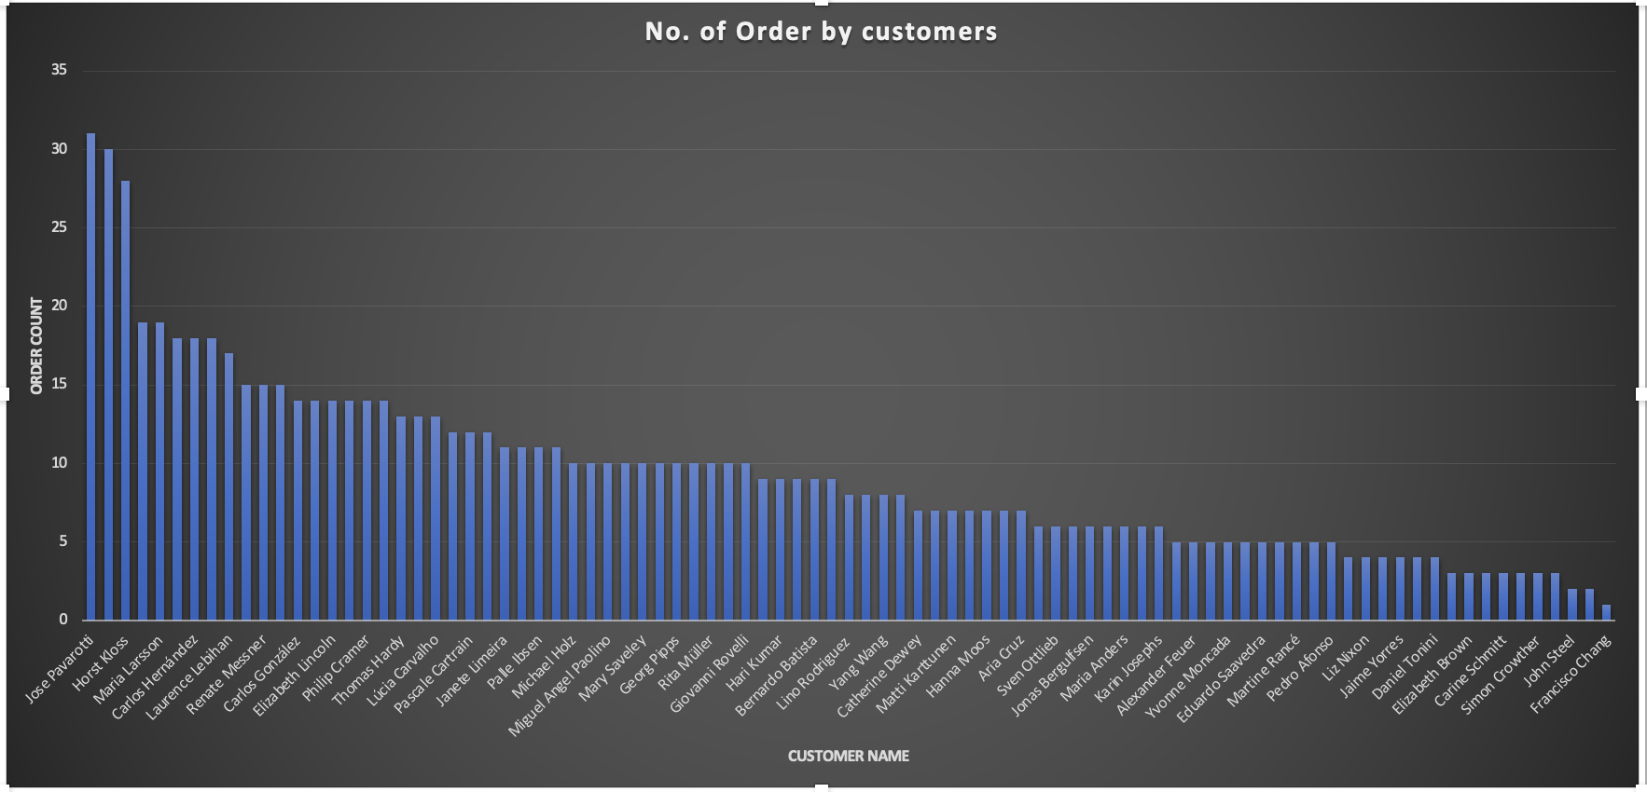

Q 2 How do customer preferences vary based on their location or demographics? Can we explore this through interactive visualizations?

The provided graph illustrates customer product preferences based on their locations. The data suggests that customers in different regions exhibit distinct preferences for certain products. Analyzing these regional preferences can offer valuable insights into consumer behavior and potentially inform targeted marketing strategies.

This graph illustrates the quantities sold for each product, with variations observed based on the customer's country. The data indicates that product preferences and sales quantities differ across different regions, emphasizing the influence of geographical factors on purchasing behavior. Understanding these variations can aid businesses in tailoring their inventory and marketing strategies to cater to specific regional demands.

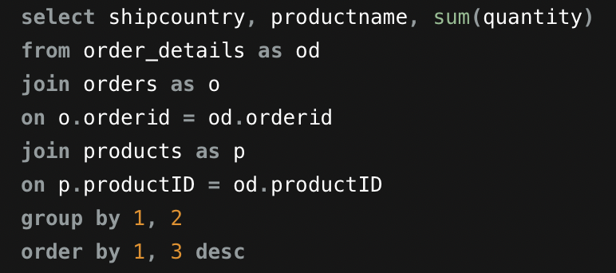

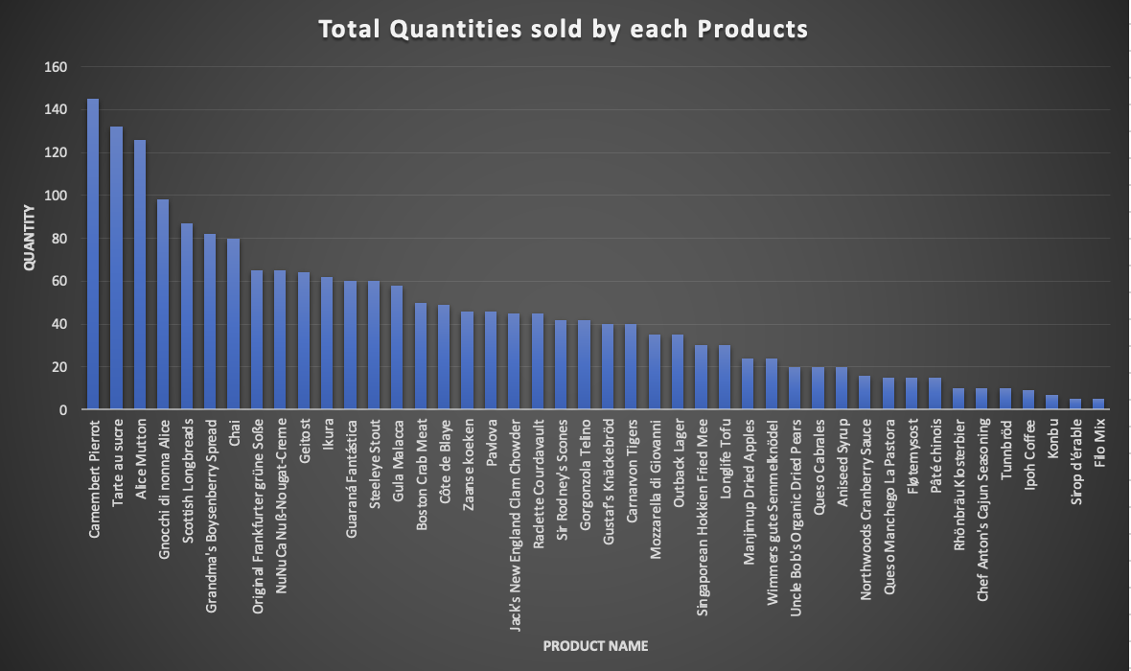

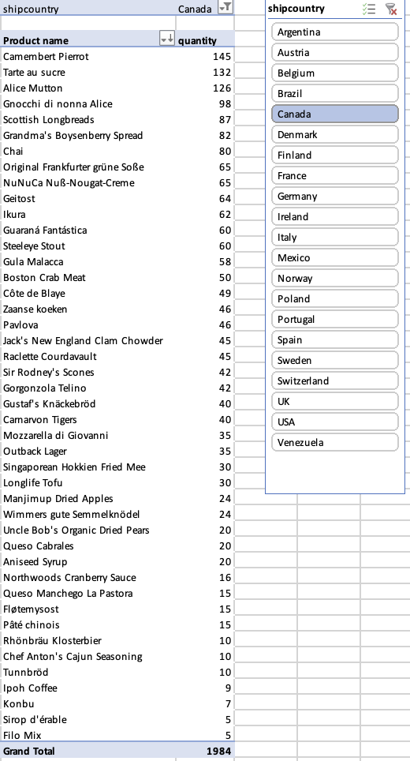

Q 3 Are there any interesting patterns or clusters in customer behavior that can be visualized to identify potential market segments?

After analyzing the sales data across all categories, it can be concluded that Beverages and dairy products contribute significantly to revenue, making them potential markets to focus on. However, it's worth noting that meat/poultry has the highest average sale per order, followed by produce, beverages, and dairy products. This insight suggests that while certain categories drive overall revenue, others might yield higher returns per individual order, influencing strategic decision-making for product promotion and marketing efforts.

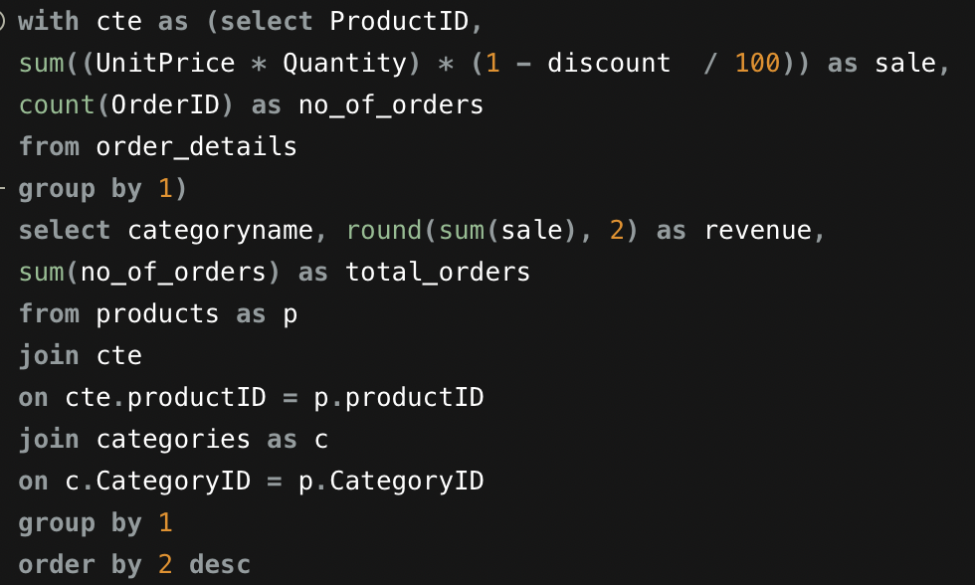

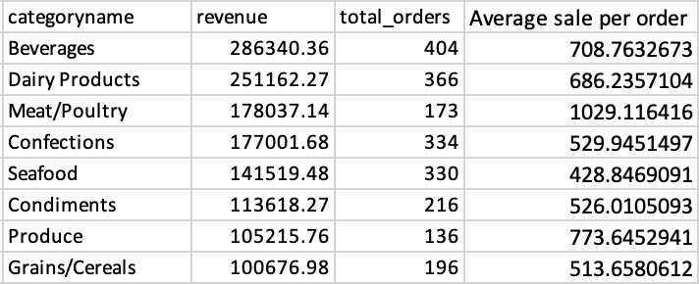

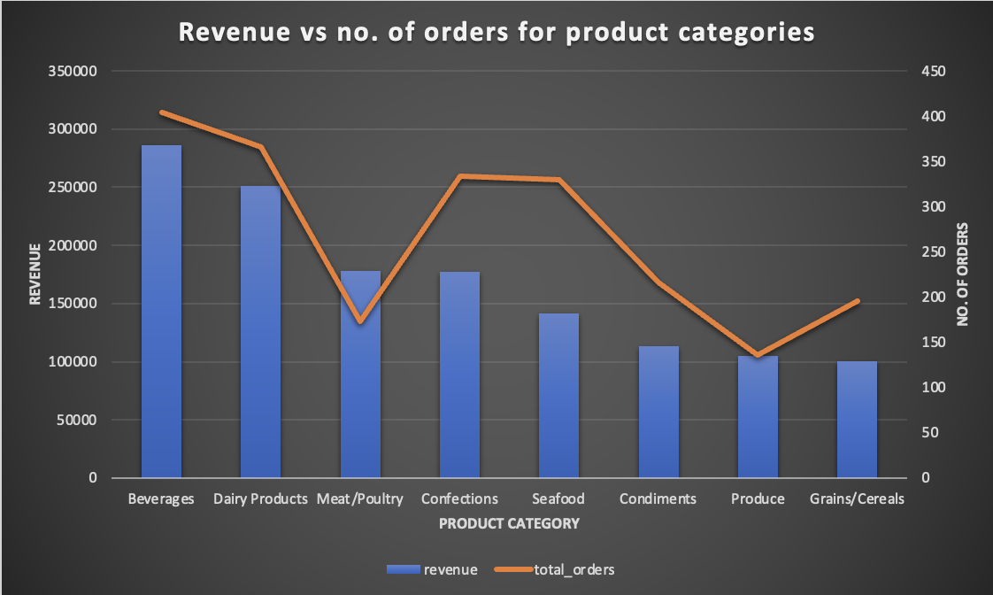

Q 4 Are there any specific product categories or SKUs that contribute significantly to order revenue? Can we identify them through visualizations?

Upon analyzing the revenue generated by all product categories through a pie chart, it can be concluded that Beverages and dairy products contribute significantly to order revenue, while grains/cereals generate relatively less revenue. This insight provides a clear understanding of the distribution of revenue across different product categories, enabling strategic decisions to enhance the performance of high-revenue categories.

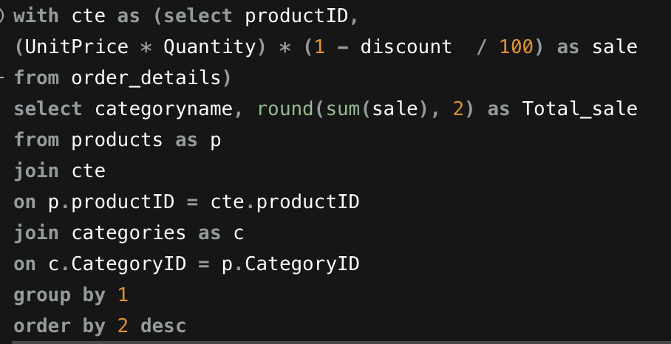

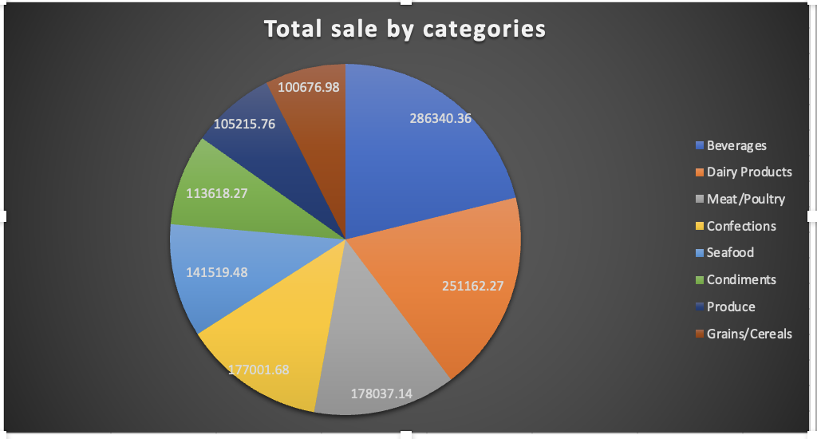

Q 5 Are there any correlations between order size and customer demographics or product categories? Can we explore this visually using scatter plots or heatmaps?

The graph illustrates a low degree of correlation between revenue and order count, suggesting that revenue tends to increase with order count, with some exceptions. The parameters analyzed include order size (revenue) and customer demographics, specifically the count of customers by countries. This observation provides valuable insights into the relationship between order volume and revenue, contributing to a comprehensive understanding of customer behavior across different regions.

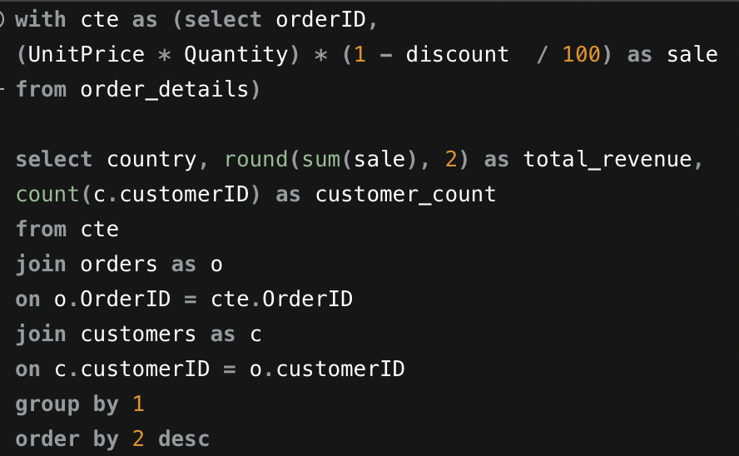

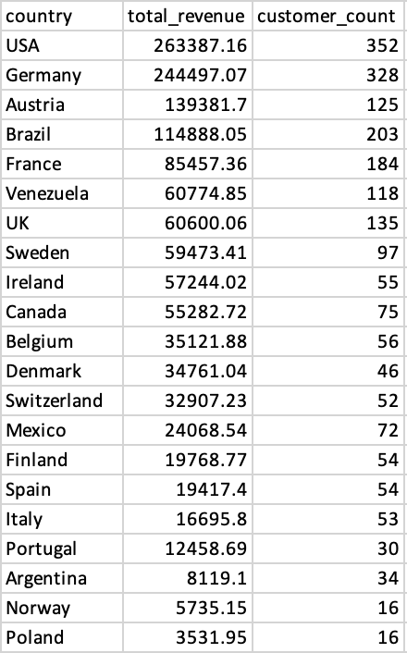

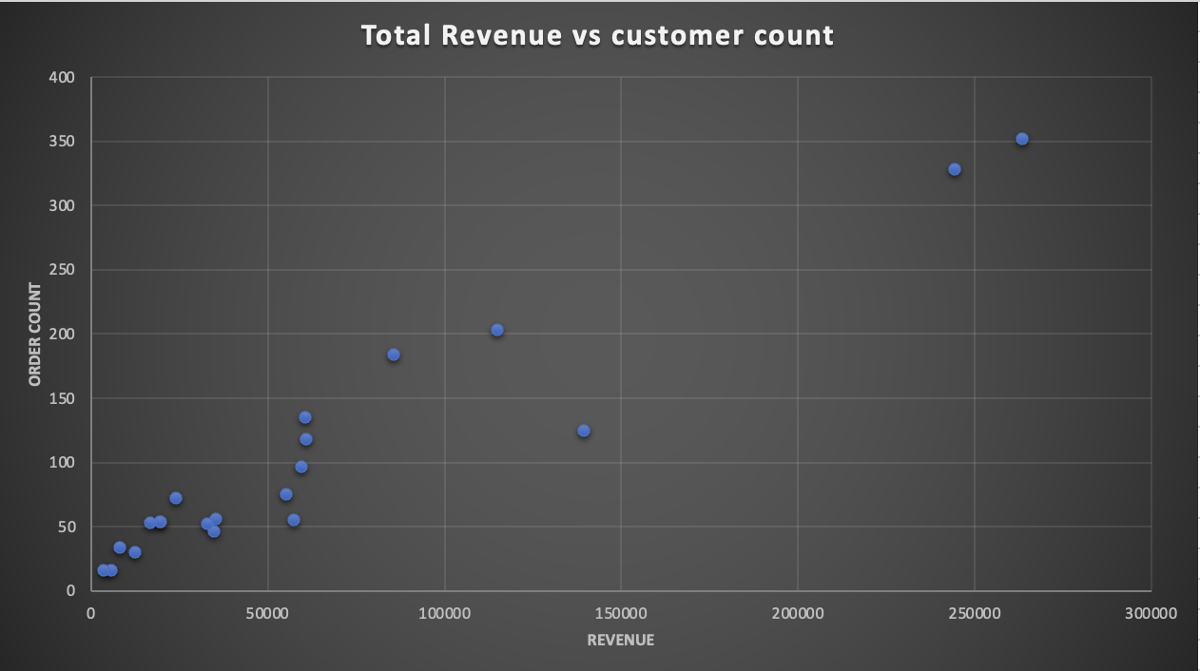

Q 6 How does order frequency vary across different customer segments? Can we visualize this using bar charts or treemaps?

The tree graph visually represents the distribution of order frequency across various customer segments or categories. In this depiction, it is evident that the beverages category exhibits the highest order frequency, showcasing its prominence. Following closely are the dairy products and confections categories, each contributing significantly to the overall order placements. This insightful visualization provides a clear hierarchy, allowing for a quick understanding of the relative importance of different customer segments in terms of order frequency.

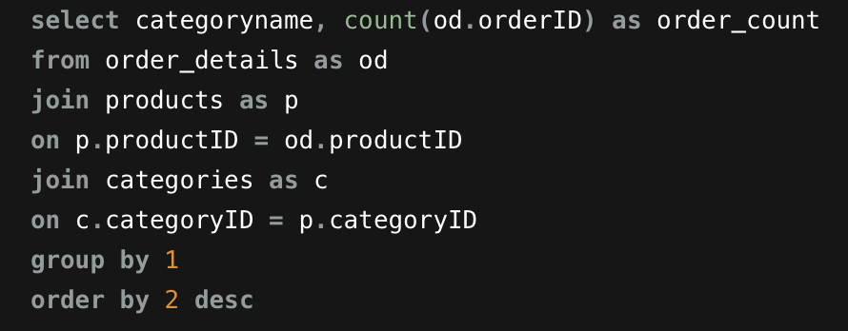

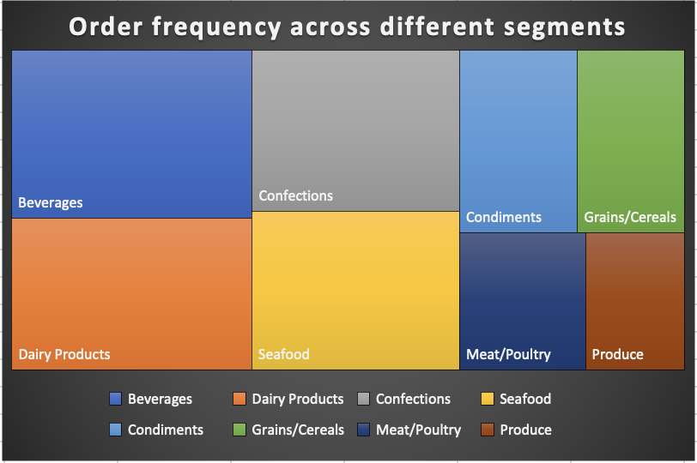

Q 7 Are there any correlations between employee satisfaction levels and key performance indicators? Can we explore this visually through scatter plots or line charts?

The graphical representation above indicates a subtle positive correlation between employee working days (reflecting on employee satisfaction levels) and the employee-generated sales (key performance indicators). While there is an observable trend of increased working days aligning with higher sales, the correlation appears to be weak. The relationship suggests that additional working days might be associated with a slight improvement in employee satisfaction and, correspondingly, a modest increase in sales performance. However, the correlation is not strongly pronounced, indicating that other factors may also contribute to employee satisfaction and overall sales performance.

The data reveals that the employee who worked for 1129 days achieved the highest sales among all employees. Additionally, noteworthy is the observation that employees with working days totaling 568 and 962 both generated nearly equal sales amounts. This suggests a relatively balanced and comparable sales performance between the employees with 568 and 962 working days. The information underscores the effectiveness and productivity of the employee with 1129 working days, while highlighting a commendable level of consistency in sales performance between the individuals with 568 and 962 working days.

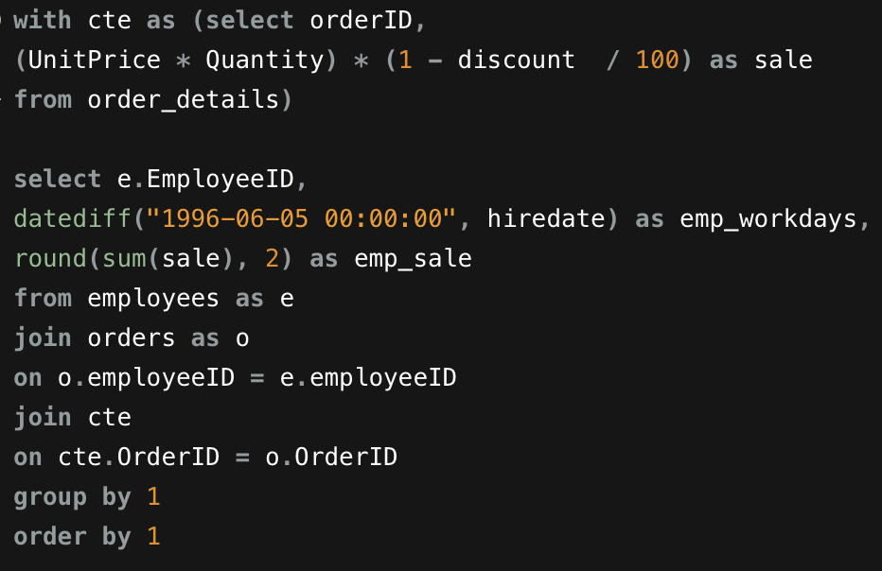

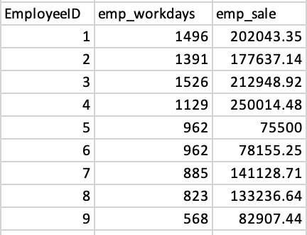

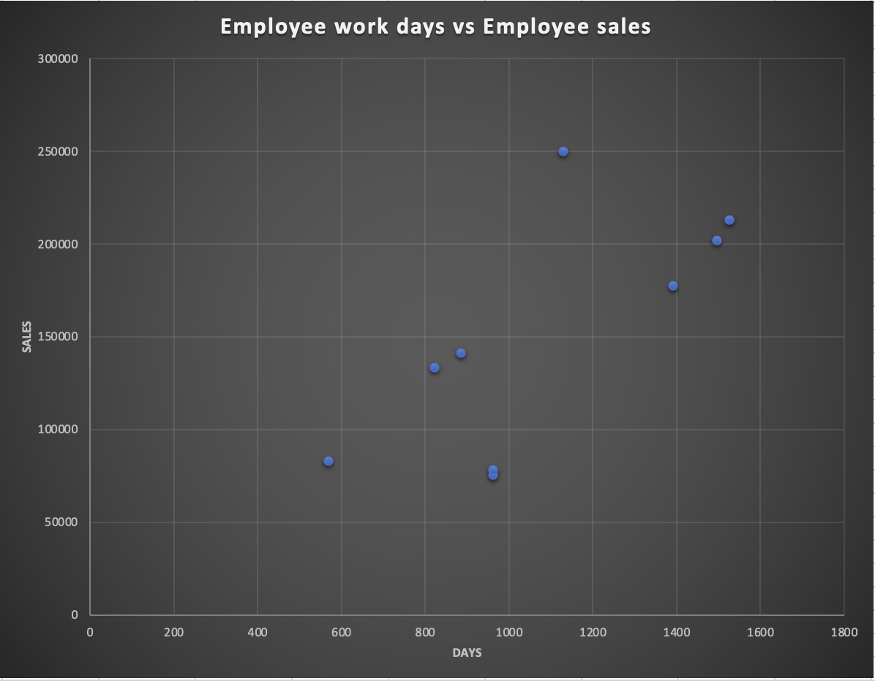

Q 8 How does employee turnover vary across different departments or job roles? Can we visualize this using bar charts or heatmaps?

The bar graph above illustrates employee turnover across various job roles, revealing that the Sales Representative department has the highest turnover. Notably, employees in the Sales Representative role are consistently within the top three positions in terms of generating sales. This correlation suggests a connection between turnover and sales performance, indicating that despite the high turnover in the Sales Representative department, individuals in this role continue to be prominent contributors to sales within the organization.

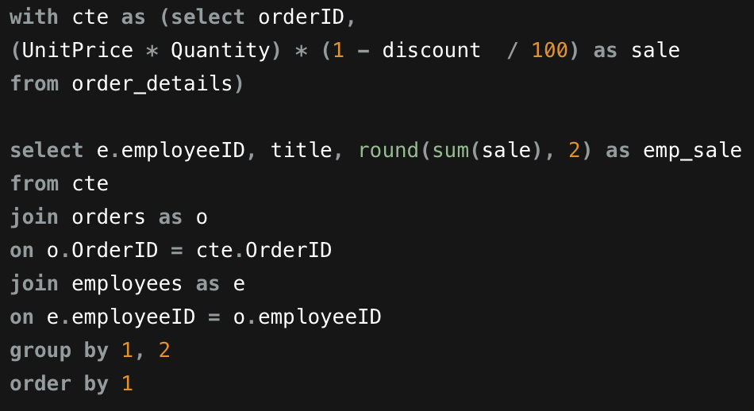

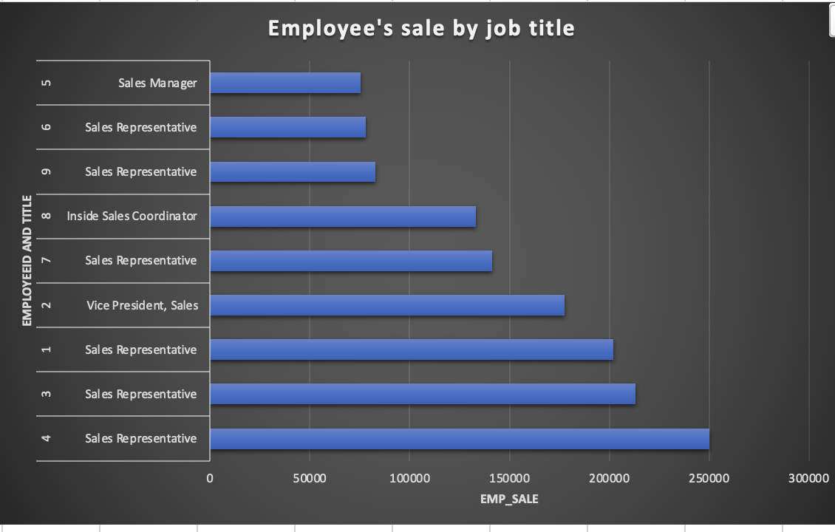

Q 9 Can we identify any patterns or clusters in employee skill sets or qualifications through visualizations? How can this information be used for talent management?

There is no relation between qualification and employee sales, it suggests that the academic qualifications of employees do not significantly influence their sales performance.

the information from the graph indicates that employees with an MA qualification tend to generate the highest revenue, followed by those with BS, BA, and Ph.D. qualifications. . Conversely, individuals with BSC, BA, and MBA qualifications contribute less to revenue generation.

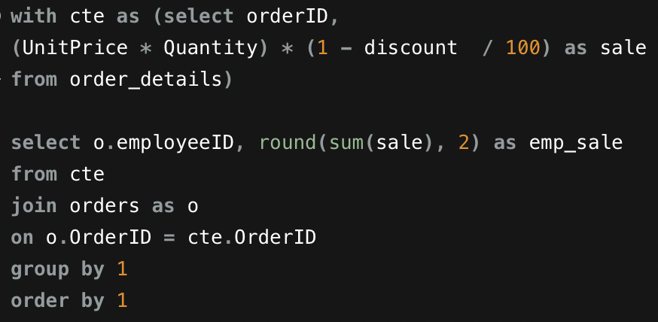

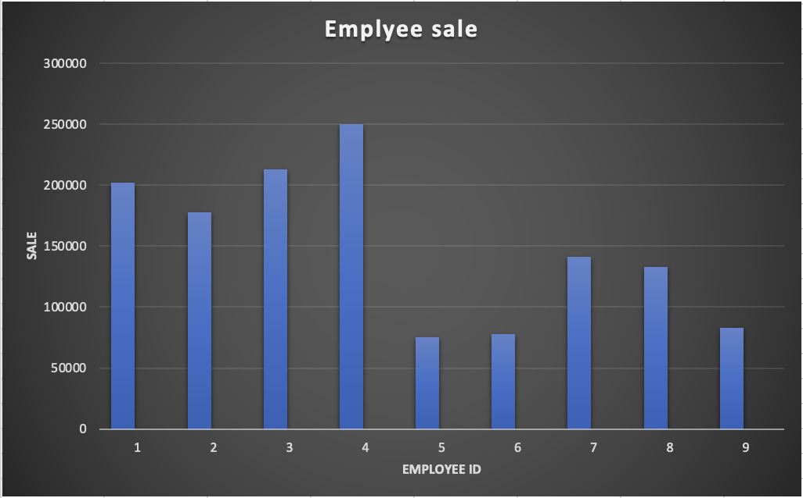

Q 10 Are there any correlations between product attributes (e.g., size, color, features) and sales performance? Can we explore this visually using scatter plots or heatmaps?

The graphical representation above reveals a weak positive correlation between product attributes, specifically unit price, and the sales of each product. Notably, there is one product distinguished by having the highest unit price, and correspondingly, this product has generated the maximum revenue among all products.

However, it's noteworthy that there are other products with higher unit prices that paradoxically generate significantly less revenue. This observation underscores the complexity of the relationship between unit price and sales revenue. In such cases, additional factors beyond unit price, such as market demand, customer preferences, competition, and perceived value, may play crucial roles in influencing the purchasing behavior and revenue generation for each product.

This nuanced understanding suggests that while unit price may contribute to revenue, other dynamic factors also contribute to the overall sales performance of individual products in a way that transcends a simple linear relationship. As a result, strategic considerations, including marketing efforts, product positioning, and market analysis, become essential in optimizing revenue generation for products with varying unit prices.

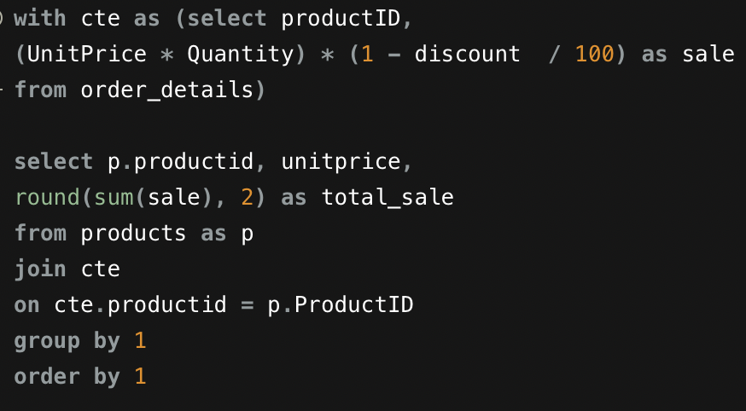

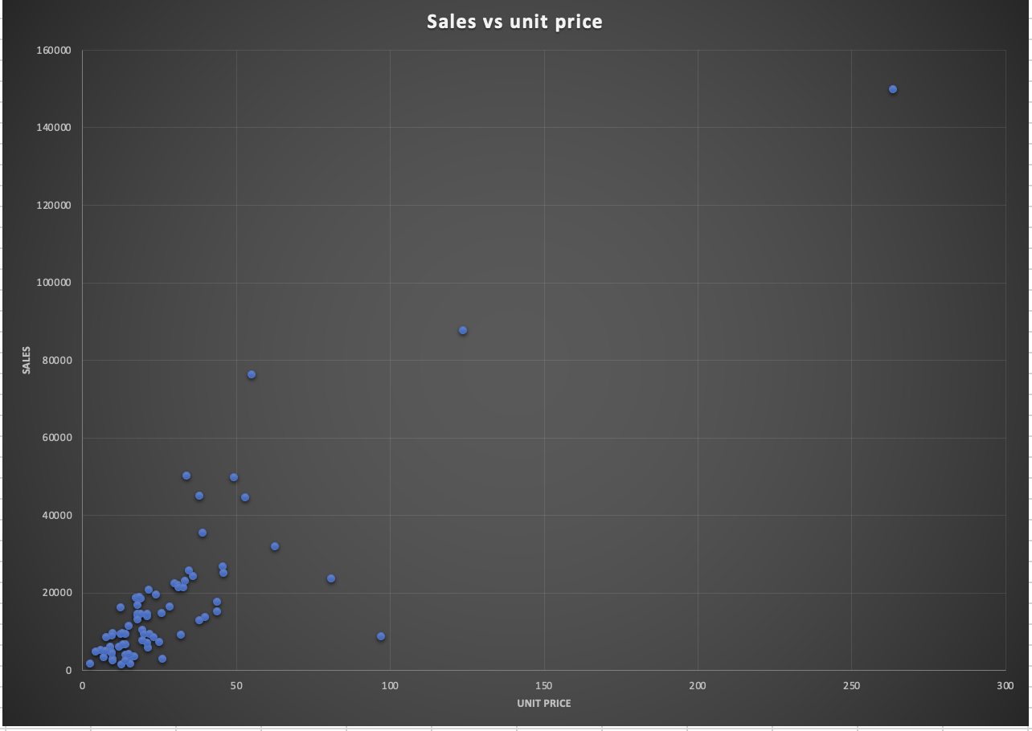

Q 11How does product demand fluctuate over different seasons or months? Can we visualize this through line charts or area charts?

The graphical representation above illustrates the fluctuation in product demand across different seasons or months. Notably, there is a discernible upward trend in product quantity sales observed from August 1994 to May 1996. This trend suggests a consistent and positive trajectory in demand over this period.

It's essential to acknowledge a slight dip in June 1996, which is attributed to incomplete data for that specific month. It's common for data gaps or incomplete records to influence the observed patterns.

Additionally, the significant surge in orders in 1996 stands out, indicating a noteworthy increase in product quantity sales during that year. This surge could be indicative of various factors such as market demand, effective marketing strategies, or new product launches contributing to heightened sales activity.

Overall, the observed trends provide valuable insights into the dynamics of product demand, and careful consideration of the context surrounding data gaps or anomalies is essential for accurate interpretation.

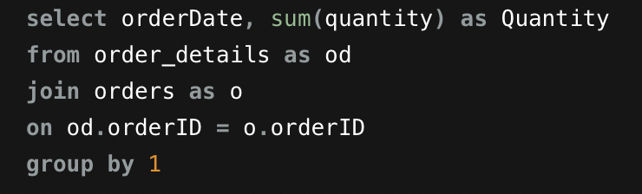

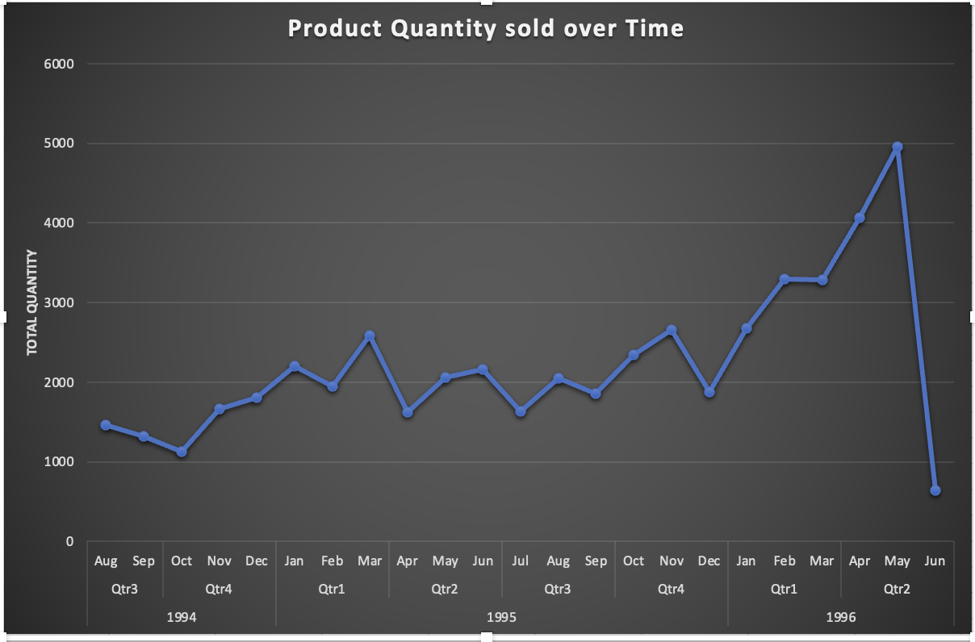

Q 12 Can we identify any outliers or anomalies in product performance or sales using visualizations? How can this information be used for product optimization?

It's clear from your observation that there is an outlier in the dataset, and the product named 'Côte de Blaye' stands out due to its exceptionally high sale of 149898.33. This sale amount is not only the highest among all the products but also significantly surpasses the average sale.

Identifying outliers is crucial in data analysis as they can have a substantial impact on statistical measures and trends. In this case, the 'Côte de Blaye' product seems to have had an extraordinary sales performance compared to other products.

Understanding the factors contributing to the exceptional performance of 'Côte de Blaye' can provide valuable insights into successful sales strategies, customer preferences, or other unique attributes of the product. Analyzing outliers can lead to actionable insights for optimizing sales and marketing strategies or identifying exceptional products in a product portfolio.

It's important to note that while removing low-selling products can be a valid strategy, careful consideration should be given to factors such as seasonality, product lifecycle, and customer preferences. Regularly monitoring and reassessing inventory strategies based on sales data and market trends will contribute to ongoing optimization efforts.

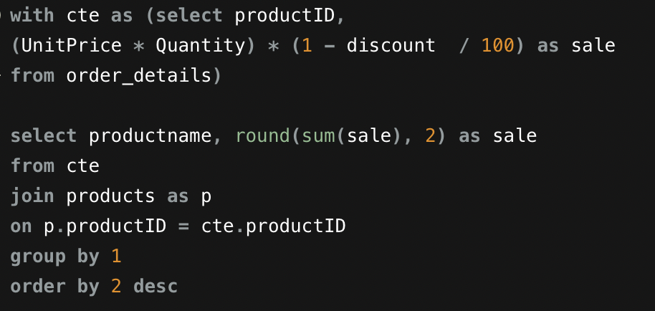

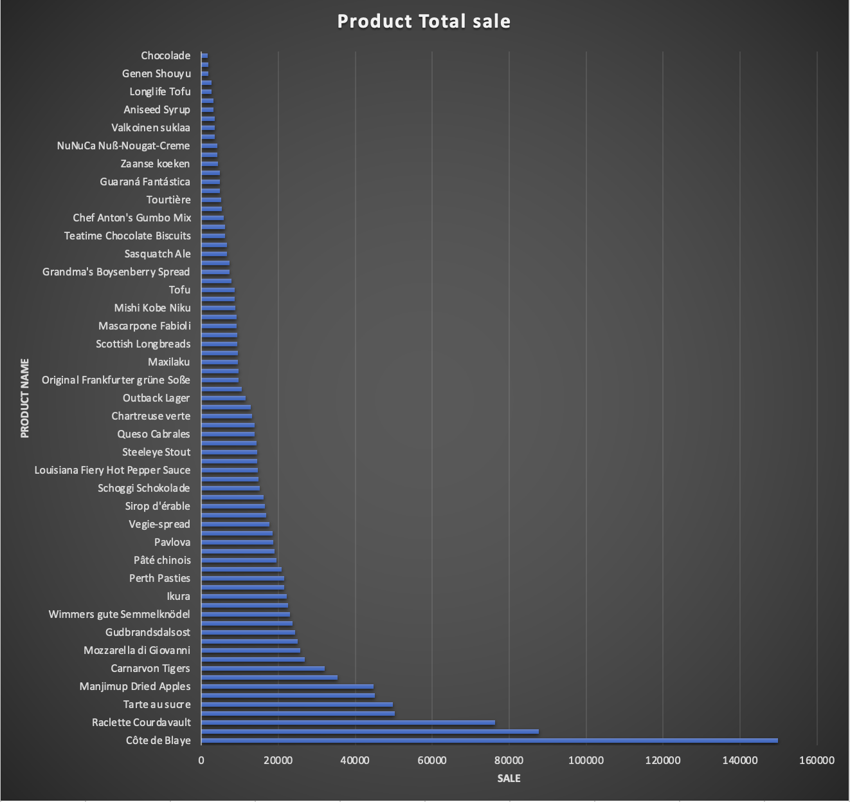

Q 13 Are there any correlations between supplier attributes (e.g., location, size, industry) and performance metrics (e.g., on-time delivery, product quality)? Can we explore this visually through scatter plots or heatmaps?

The provided graph, illustrating the correlation between supplier countries and delivery status categorized as on-time, late, or not delivered, offers valuable insights into the performance metrics of different regions. Based on the analysis, it can be concluded that the United States, Germany, and Australia exhibit the highest on-time delivery rates among the supplier countries. Additionally, the graph highlights the exceptional performance of the Netherlands, achieving a 100% on-time delivery rate.

This conclusion suggests that the supply chains associated with suppliers from the United States, Germany, Australia, and the Netherlands are particularly effective in meeting delivery timelines. This information is crucial for supply chain management and can guide decision-makers in optimizing relationships with suppliers from these regions. Furthermore, it opens avenues for studying the operational practices and factors contributing to the success of these countries in achieving on-time deliveries, enabling the implementation of best practices across the supply chain.

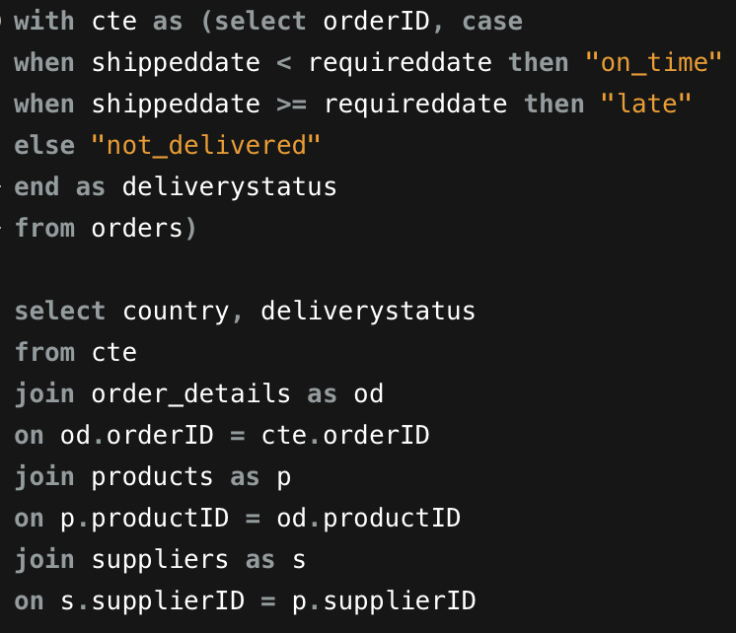

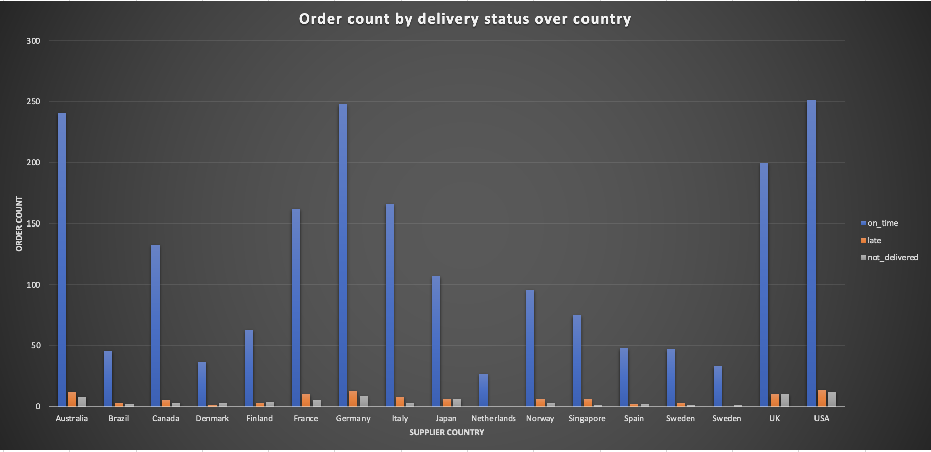

Q 14 How does supplier performance vary across different product categories or departments? Can we visualize this using stacked bar charts or grouped column charts?

The graph depicting supplier performance across different product categories reveals notable variations in reorder levels. Specifically, the category of grains/cereals stands out with the highest reorder level, surpassing other product categories. Following closely, the beverages category exhibits a substantial but comparatively lower reorder level. In contrast, the product categories of meat/poultry and produce display considerably lower reorder levels.

This information provides valuable insights into supplier performance metrics across diverse product categories. The higher reorder levels in grains/cereals and beverages suggest efficient and timely replenishment of stock for these items, potentially indicating robust supplier relationships and effective inventory management practices. Conversely, the lower reorder levels in meat/poultry and produce categories may warrant further analysis to identify opportunities for improvement in supplier performance, supply chain efficiency, or demand forecasting in these specific product segments. Overall, the graph offers a comprehensive view of how different suppliers perform across distinct product categories, enabling strategic decision-making in supply chain management and inventory optimization.

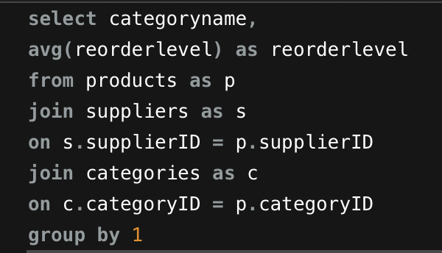

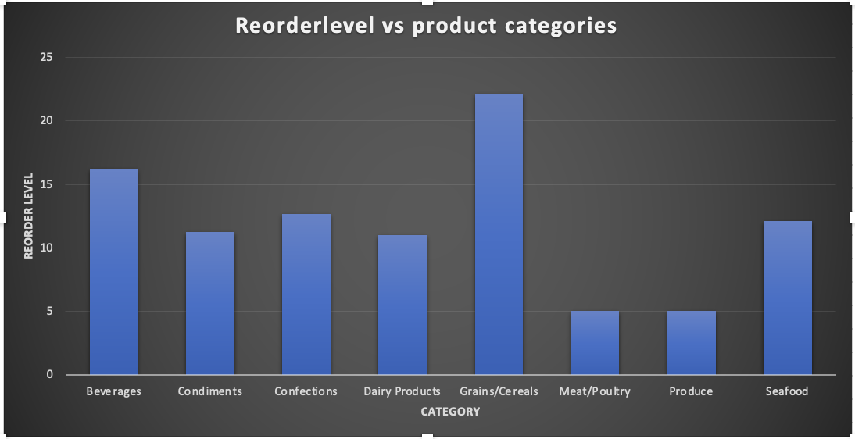

Q 15 Can we identify any trends or patterns in supplier costs or pricing structures through visualizations? How can this information be used for procurement optimization?

The stability observed in supplier unit prices over time suggests a need for strategic optimization in procurement practices. To enhance efficiency and achieve cost savings, organizations should prioritize key initiatives such as demand forecasting, continuous performance monitoring, and market research. Strengthening demand forecasting capabilities allows for precise anticipation of future requirements, enabling better inventory management and negotiation positions. Continuous performance monitoring of suppliers against predefined KPIs ensures adherence to quality standards and identifies areas for improvement. Regular market research is essential for benchmarking supplier prices, staying informed about industry trends, and identifying potential cost optimization opportunities. Additionally, fostering strong supplier relationships, incorporating contract flexibility, and embracing technology solutions contribute to streamlined procurement processes. With a comprehensive approach that integrates these initiatives, organizations can navigate a stable pricing environment, optimize procurement operations, and position themselves for sustained success in the dynamic marketplace.

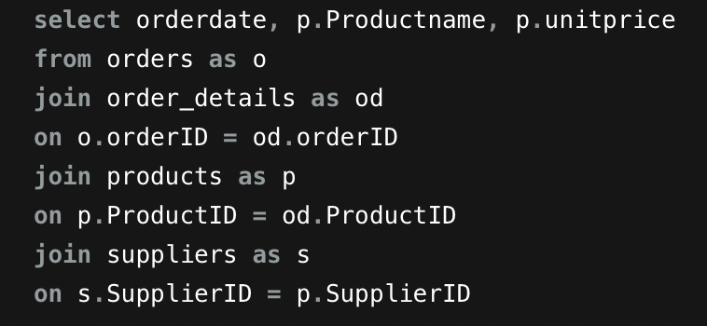

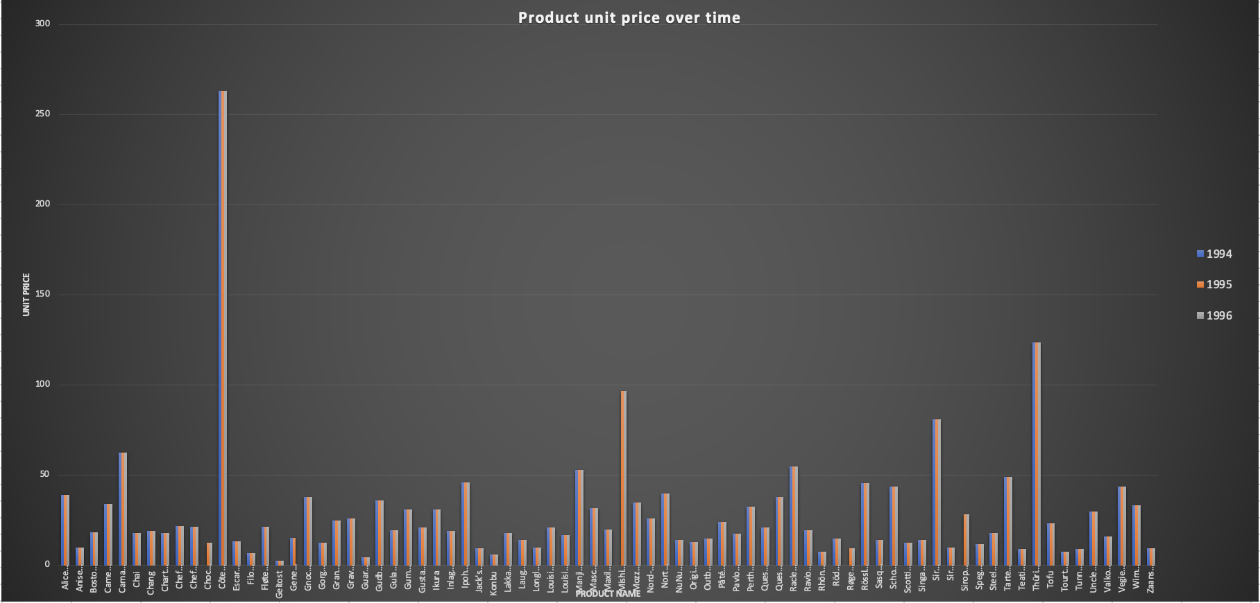

**CONCLUSION**

The comprehensive analysis of the Northwind Sales dataset using SQL, EDA, and Power BI provides valuable insights across multiple facets of the business. By focusing on key performance indicators (KPIs) for customers, suppliers, products, orders, and categories, the organization gains a holistic view of its operations. This approach enables data-driven decision-making, allowing for the identification of strengths, areas for improvement, and strategic opportunities. Ultimately, the derived insights empower the organization to enhance customer relationships, optimize supplier collaborations, refine product offerings, streamline order processes, and align marketing strategies with category trends, contributing to overall business growth and efficiency.